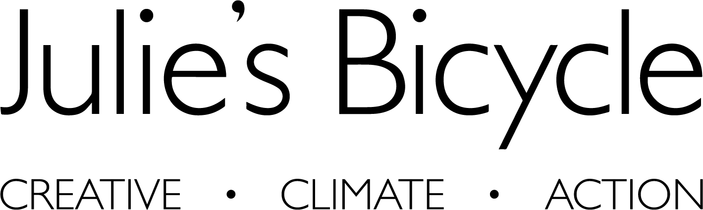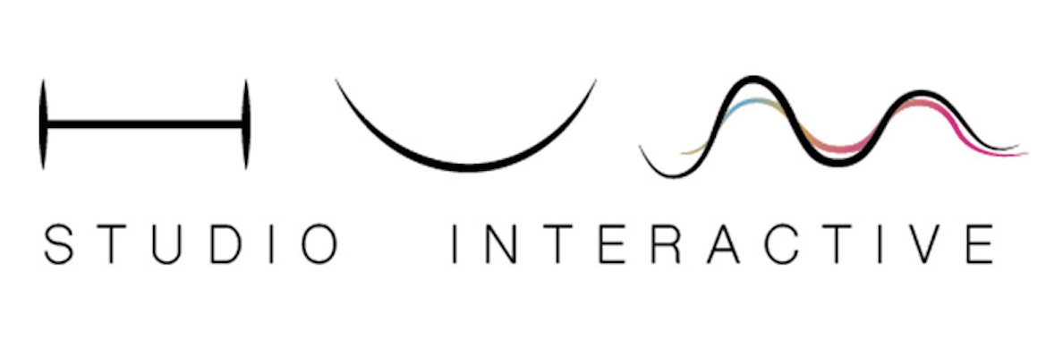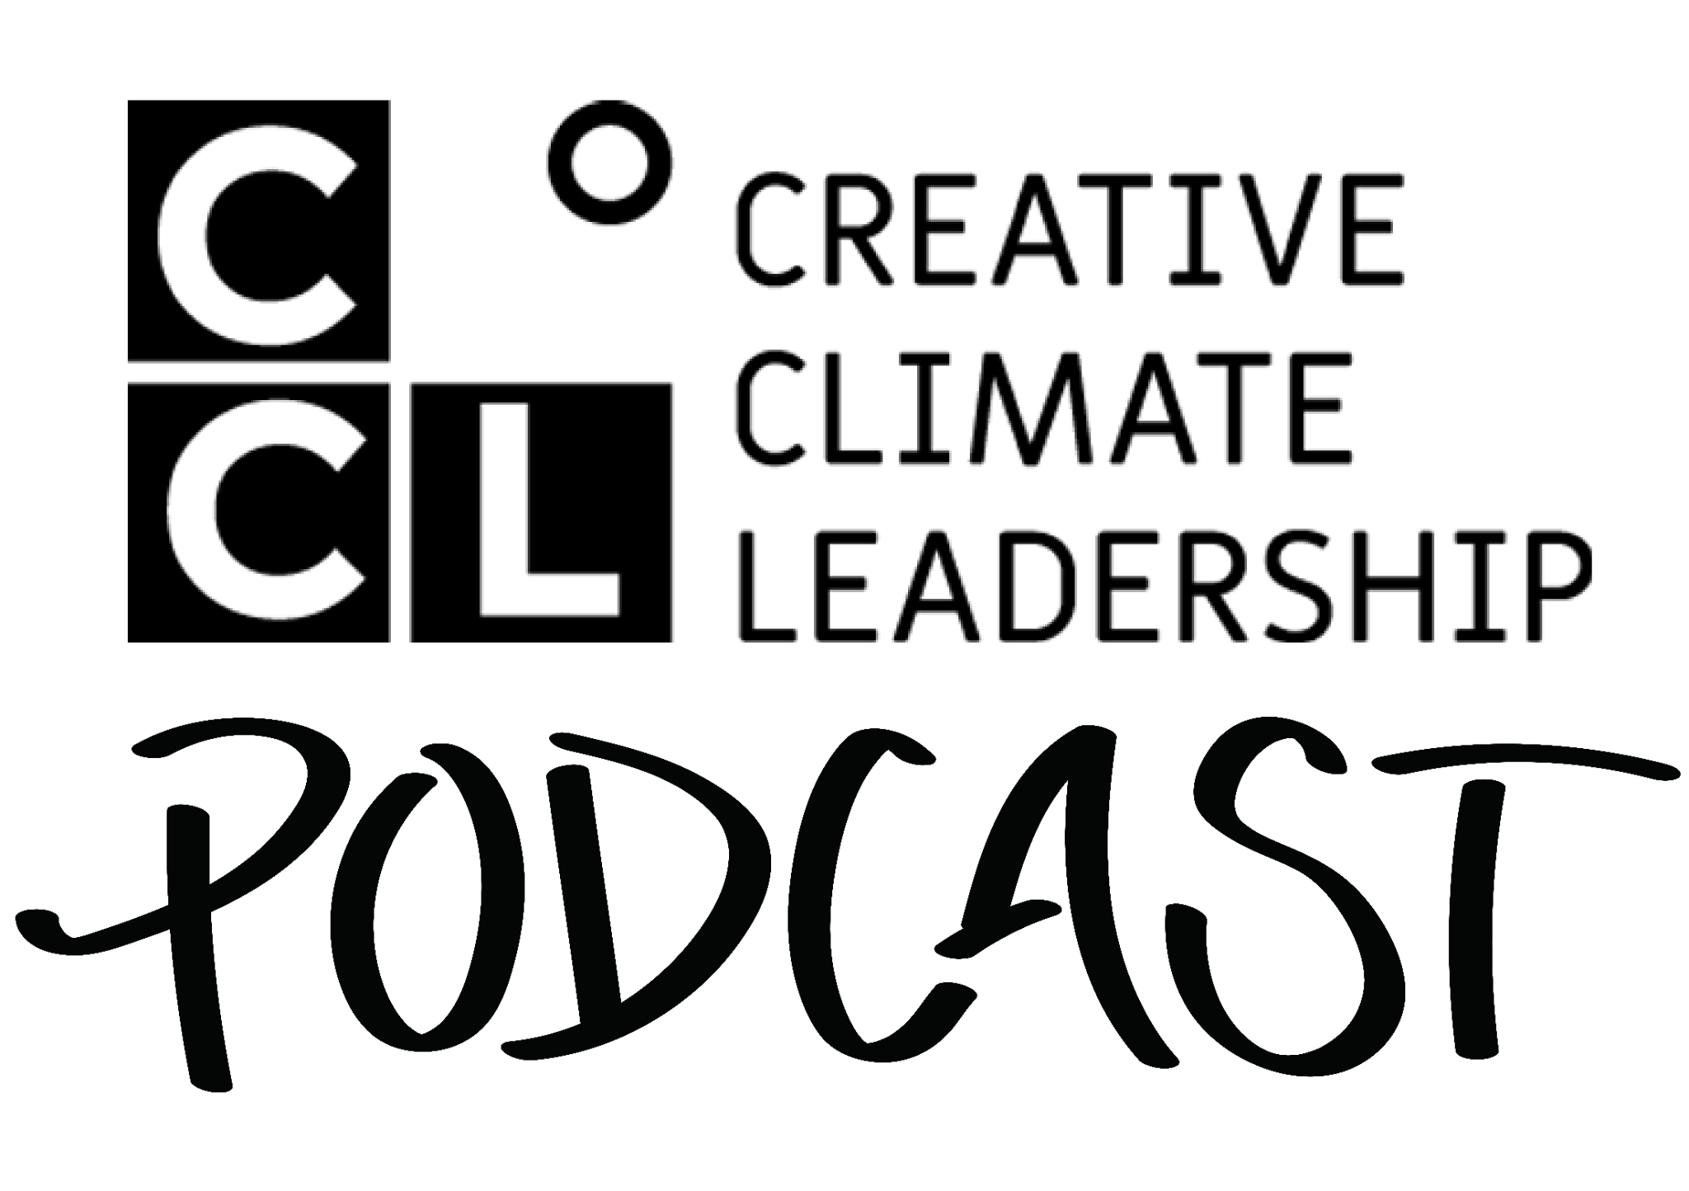

Creative Climate Leadership Podcast
Meet our host
Transcription
{Diego}
0:03
Welcome, welcome and thank you for tuning into the Creative Climate Leadership Podcast. Here we explore the transformative role of the arts in responding to our time of converging crises. I'm Diego Galafassi, producer of this series together with Julie's Bicycle Team. And I'm thrilled to be here today with a very special guest, the host of our show, Emmanuella Blake Morsi.
Hello, Emmanuella, it's great to have you on board.

{Emmanuella}
0:30

Thank you so much for having me. Honestly, I'm so blessed and honored to be the host. And I can't wait to get into all the different themes across the whole series.
{Diego}
0:42

Excellent, but before we go into these conversations, could you share a little bit about yourself, your practice, and what drove you to be the host of this podcast?
{Emmanuella}
0:52
Well, I'm Emmanuella Morsi, and I've got over a decade in the creative industry with a lot of work as an award-winning multi-disciplinary arts producer, predominantly working across so many different types of mediums from film to sound, photography, graphics, and events. Really looking at how to use storytelling as a way to immerse people to climate and nature, but also kind of integral to producing work that can be experienced by all, but most importantly for me, gives visibility to and engages those from marginalised groups. And I was super fortunate to take part in CCL UK, 2023. And that was a seriously life-changing experience in being able to connect so meaningfully with just changemakers and creatives and visionaries who across different types of fields have been kind of passionately working in their communities and across the globe and internationally to make real change. And I think if we had just come and as, you know, people who cared about it and as professionals, it would have been an amazing experience, but people were so generous and given in their fullness. We really met as real people, not just, you know, professionals in a way. And I think actually what made that difference meant that we created and cultivated this, this like mycelium network of information and of community. And that really galvanised me to really feel like there's so much power when we come together and to then have a wider network that is global. Where there’s people all over the world doing amazing, incredible things, I couldn't imagine ever not wanting to be a part of something so special like this.

{Diego}
02:40
Wonderful, so inspiring. And what are you hoping our listeners will take away from this series?
{Emmanuella}
02:47
I really truly hope that listeners take away the fact that they too can be changemakers. I think you don't have to be someone who gets validated by this. I think we all have a right to care about the climate. We all have a right to want a better quality of life. And I think actually, if anything, we need to have people in different situations across the world almost disrupting what we think is possible, but equally to then start rebuilding together. And if this can spark within someone a desire to meaningfully connect, to meaningfully push those boundaries, that for me feels like it's doing the work.
{Diego}
03:27
I'm looking so much forward to this journey with you and with our audience. And if people would like to find out more about your work, where could they find you?
{Emmanuella}
03:37
So you can find me at emmablakemorsi.co.uk. I'm currently developing an inclusive design framework called Access as a Creative Tool. And it's basically a way of leveraging inclusive and accessible design factors to really address better products and better processes that are able to kind of reimagine how we source, but also extending life cycles and looking at how we kind of take people on that journey together. And very excited to be developing this in a new fellowship. So I really see kind of how this can impact the kind of wider work that I do across Europe, the Middle East, Latin America, North America and Asia and beyond. So very blessed. And also Africa. Wow, how can I forget my own? So very excited to have this work continue and to be a part of something so special.

{Diego}
04:27

That's Emmanuella Blake Morsi. I hand over to you now and thank you so much for hosting this show.
{Emmanuella}
04:33
Thank you so much.

This podcast is constructed by the Creative Climate Leadership Alumni Network, an evolving network growing from the CCL programme led by Julie’'s Bicycle, a pioneering UK-based nonprofit mobilising the arts and culture to take action on the climate and ecological crisis. Don't miss an episode. Subscribe to the Creative Climate Leadership Podcast and get in touch with us on ccl@juliesbicycle.com.

And I would love to thank the CCL Podcast team. Diego Galafassi, Danielle McMaster, Farah Ahmed, Chiara Badiali, Ruby Kvalheim, Sheena Balkwill, Sarah Leech, Helen Brown, Edwina McEachran, Pascal Terra Déau and Alison Tickell. And the whole CCL Alumni Network.

This podcast is produced by Hum Studio Interactive in co-creation with Julie’s Bicycle, with support from Nordisk KulturFond, Swedish Postcode Lottery, and Porticus.

